পরিশিষ্ট – ৬: Workout example of Construction Management Plan (CMP) of a Project


CONSTRUCTION MANAGEMENT PLAN (CMP)
For
Construction of Six Storied Anti-Corruption Commission Divisional Office Building with Six Storied Foundation at Khulna

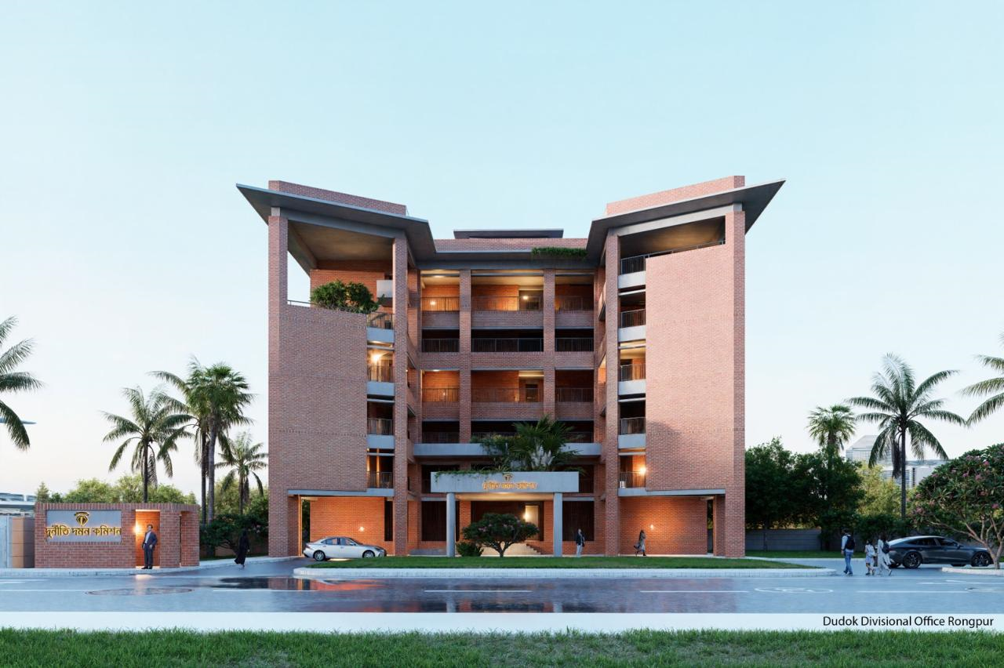

Initiating Agency: Anti-Corruption Commission (ACC), Bangladesh
Implementing Agency: Public Works Department (PWD)

Prepared By: Executive Engineer, Khulna PWD Division-1, Dhaka

TABLE OF CONTENTS
1. Project Information
2. Organizational Structure
2.1 Organizational Chart
2.2 RACI Matrix of the Project
2.3 Stakeholder Contact Chart
3. Scope of Work
3.1 Key Activities
3.2 Site Preparation
3.3 Earthworks
4. Time Management
4.1 Work Breakdown Structure (WBS)
4.2 Time Control
4.3 Steps of Construction
4.4 Work Schedule
5. Resource Management
5.1 Tools & Equipment Plan
5.2 Material Procurement Plan
5.3 Traffic & Logistics Management
6. Risk Register
7. Quality Control
7.1 Testing requirements
8. Health, Safety & Environment (HSE) Plan
8.1 Storm water and Wastewater Management
8.2 Noise Monitoring
8.3 Air Quality, Dust Control & Monitoring
8.4 Emergency Response Plan
9. Cost Control
10. Sample Checklist
11. Documentation Checklist
12. Completion and Handover
CONSTRUCTION MANAGEMENT PLAN (CMP)
for
“Construction of Six Storied Anti-Corruption Commission Divisional Office Building with Six Storied Foundation at KHULNA”

- Project Information

Project Name : Construction of Six Storied Anti-Corruption Commission
Divisional Office Building with Six Storied Foundation
Location : Khulna, Bangladesh
Initiative Division : Anti-Corruption Commission (ACC), Bangladesh
Implementing Agency : Public Works Department (PWD)
DPP Value : BDT 2556.00 Lakh
Project Duration : April 2024-June 2028 (50 Months)
Tender ID : 1119586
Contractor Name : ABC Construction Ltd.
Contract Value : BDT 1912.36 Lakh
Date of Contract : 14 August 2024
Contract Duration : 24 Months
Type of Building : Divisional Office Building
Number of Floors : 6 Nos
Total Floor Area : 34500 Sq. ft
Structural System : RCC Frame Structure
Foundation Type : Pile foundation
Utilities : Divisional and District office Building. Multipurpose Hall,
Library, Conference Room, Prayer Room, Record Room, Barrack Zone, Sub-station, Generator, Lift, Fire hydrant System, HVAC System, CCTV System, Conference System and Sound System

- Organizational Structure

  - Organizational Chart

Organizational chart of ABC Construction

Note
** Information given here are to be modified according to organizational data given by the contractor.
** This Organizational chart is to be prepared accordingly following section 2.1 of CMP guideline.

Organizational chart of Khulna Division-1 for Construction of ACC Divisional Office, Khulna
Chief Engineer

EE, Khulna Division-1 (Project Manager)

ACE, Khulna Zone

AE, Khulna Division-1

SE, Khulna CIrcle

Estimator

SDE, Khulna Sub-Division 1

SAE, Khulna Sub-Division 1
(SAE)

Work Assistant

  - RACI Matrix of the Project

Steps of Work | Client | Architect | Design Engineer | EE | SDE | SAE | Contractor | Site Engineer
Drawing Collection & Preservation |  | C | C | I | A | R
Site Handover to Contractor | I |  |  | A | R | I
Monitoring of Daily Work |  | C | C | C | A | R | R | R
Monthly Progress Report |  |  |  | C | A | R | I
Inspection Report |  |  |  | C | A | R | I
Work Schedule/ Bar Chart |  |  |  | C | C | R | A
Approval of Material (Structural) | I |  | I | A | R | I | R
Approval of Material (Finishing Item) | A | A |  | A | R | I | R
Record of Measurement Book (MB) |  |  |  | I | A | A | R | R
Preparation of Running Bill |  |  |  | I | A | R | R | R
Approval of Bill |  |  |  | A | R | I | I
Quality Control | I | C | C | A | R | R | R | R
Final Project Handover | A |  |  | A | R | I | I

- R – Responsible
Note
** Information given here are to be modified according to different types of works in different projects.
** This RACI Matrix is to be prepared accordingly following section 2.2 of CMP guideline.
- A – Accountable
- C – Consulted
- I – Informed

  - Stakeholder Contact Chart

Stakeholders |  | Name & Designation | Office Address | Phone/ Mobile | E-mail | Remarks (if any)
Ministry/ Client Part | Project Director (PD) |  | Anti-Corruption Commission | 01XXXXXXXXX
PWD Part | Architect | Assistant Arch | Division-2, DoA | 01XXXXXXXXX
PWD Part | Architect | Executive Arch | Division-2, DoA | 01XXXXXXXXX
PWD Part | Structural Design Engineer | SDE/ AE | Design Division-6 | 01XXXXXXXXX
PWD Part | Structural Design Engineer | EE | Design Division-6 | 01XXXXXXXXX
PWD Part | Plumbing Engineer | EE | Plumbing Unit-2 | 01XXXXXXXXX
 | E/M Planning | EE | EM Planning Division | 01XXXXXXXXX
 | E/M Design | EE | EM Design Division | 01XXXXXXXXX
 | E/M P&D | EE | EM P&D Division | 01XXXXXXXXX
 | Project Monitoring Divisions | EE | Project Division-2 | 01XXXXXXXXX
 | PWD Field Office | EE (Civil) | Khulna Division-1 | 01XXXXXXXXX
 | PWD Field Office | EE (EM) | Khulna Division-1 | 01XXXXXXXXX
 | PWD Field Office | SDE (Civil) | Khulna Sub-Div-1 | 01XXXXXXXXX
 | PWD Field Office | SDE (EM) | Khulna Sub-Div-1 | 01XXXXXXXXX
 | PWD Field Office | SAE (Civil) | Khulna Sub-Div-1 | 01XXXXXXXXX
 | PWD Field Office | SAE (EM) | Khulna Sub-Div-1 | 01XXXXXXXXX
Contractor Part | The main contractor for this project is:  ABC Construction  Address: …………………
Contractor Part | Project Director | Mr. Engr. A | ABC Construction Ltd. | 01XXXXXXXXX
Contractor Part | Project Manager | Mr. Engr. B | ABC Construction Ltd. | 01XXXXXXXXX
Contractor Part | Project Engineer | Mr. Engr. C | ABC Construction Ltd. | 01XXXXXXXXX
Contractor Part | Site Engineer | Mr. Engr. D | ABC Construction Ltd. | 01XXXXXXXXX
Contractor Part | Electrical Engineer | Mr. Engr. E | ABC Construction Ltd. | 01XXXXXXXXX
Contractor Part | Accountant | Mr. F | ABC Construction Ltd. | 01XXXXXXXXX
Contractor Part | Mixer Machine operator | Mr. G | ABC Construction Ltd. | 01XXXXXXXXX
Contractor Part | Curing man | Mr. H | ABC Construction Ltd. | 01XXXXXXXXX
Contractor Part | Security Guard | Mr. I | ABC Construction Ltd. | 01XXXXXXXXX
Contractor Part | Security Guard | Mr. J | ABC Construction Ltd. | 01XXXXXXXXX
Contractor Part | Office Peon | Mr. H | ABC Construction Ltd. | 01XXXXXXXXX

Vendor/ Supplier List

Sl. No. | Construction Materials | Supplier | Name | Mobile Number
1. | Stone chips | ……. Comapany | Mr. A | 01XXXXXXXXX
2. | Sylhet Sand | ……. Comapany | Mr. B | 01XXXXXXXXX
3. | Sylhet Sand | ……. Comapany | Mr. C | 01XXXXXXXXX
4. | Sylhet Sand | ……. Comapany | Mr. D | 01XXXXXXXXX
5. | Local Sand | ……. Comapany | Mr. E | 01XXXXXXXXX
6. | Bricks | ……. Comapany | Mr. F | 01XXXXXXXXX
7. | Cement | ……. Comapany | Mr. G | 01XXXXXXXXX
8. | Cement | ……. Comapany | Mr. H | 01XXXXXXXXX
9. | M.S Rod | ……. Comapany | Mr. I | 01XXXXXXXXX
10. | M.S Rod | ……. Comapany | Mr. J | 01XXXXXXXXX
11. | Tiles | ……. Comapany | Mr. K | 01XXXXXXXXX
12. | Paint | ……. Comapany | Mr. L | 01XXXXXXXXX
13. | Thai-Aluminium | ……. Comapany | Mr. M | 01XXXXXXXXX
14. | Grill | ……. Comapany | Mr. N | 01XXXXXXXXX
15. | Sanitary | ……. Comapany | Mr. O | 01XXXXXXXXX
16. | Lift | ……. Comapany | Mr. P | 01XXXXXXXXX
17. | PABX | ……. Comapany | Mr. Q | 01XXXXXXXXX
18. | Fire-hydrant | ……. Comapany | Mr. R | 01XXXXXXXXX
19. | CCTV System | ……. Comapany | Mr. S | 01XXXXXXXXX
20. | Sound System | ……. Comapany | Mr. T | 01XXXXXXXXX
21. | Sub-Station | ……. Comapany | Mr. U | 01XXXXXXXXX
22. | Generator | ……. Comapany | Mr. V | 01XXXXXXXXX
Vendor Control System:
All vendors shall comply with:
- Approved sample submission
- Material Test certificates
- Delivery Challan, Invoice, Service warranty (if any), manufacturer guideline, user guide etc. documentation
- Engineer’s approval prior to bulk supply
Emergency Contact:
Nearby Police Station : X Thana, 01XXXXXXXXX
Nearby Fire Station: Y Fire Station, 01XXXXXXXXX
Nearby Hospital: Z Hospital, 01XXXXXXXXX
Ambulance: 01XXXXXXXXX
Note
** These charts are to be prepared accordingly following section 2.4 of CMP guideline.

- Scope of Work
3.1 Key Activities
Phase Identification | Steps of Work | Scope of Work | Remarks
Phase-1: Foundation Work | Pre-Construction Works | - Collection of Approved Architectural & Structural Drawing  - Soil Investigation  - Construction Schedule  - Site Clearing  - Site Layout
Phase-1: Foundation Work | Substructure | - Excavation  - Shoring  - Pile work  - Grade Beam
Phase-2: Structural Work | Superstructure | - Column  - Beam  - Slab  - Staircase  - Brick Work
Phase 3: Finishing Work | Finishing Works | - Plaster  - Tiles  - Painting  - Door & Window Installation
Phase 4:  Services & External Work | MEP Works | - Sanitary & Plumbing works  - Electrical Wiring  - Substation, Generator, Power Connection  - Lift Supply & Installation works  - Fire Hydrant System Installation  - HVAC System Installation  - CCTV System Installation  - Conference System Installation  - Sound System Installation
Phase 4:  Services & External Work | External Works | - Boundary Wall  - Drainage  - Landscaping
Phase 5:  Project Completion | Completion and Handover | - Testing & Commissioning plan  - Generator & Substation Test  - Lift inspection & Elevator load testing  - Fire system full-scale simulation  - HVAC balancing and testing  - Water pressure testing  - Integrated system commissioning  - MEP testing procedures  - Fire pump testing  - Electrical Insulation Test  - CCTV and Conference system Test
Note
** Scope of work given here are to be modified according to different types of works in different projects.
3.2 Site Preparation

Site Description
The project is located in Khulna. The proposed construction is a modern six storied government office building including all essential utilities, services, and security systems.
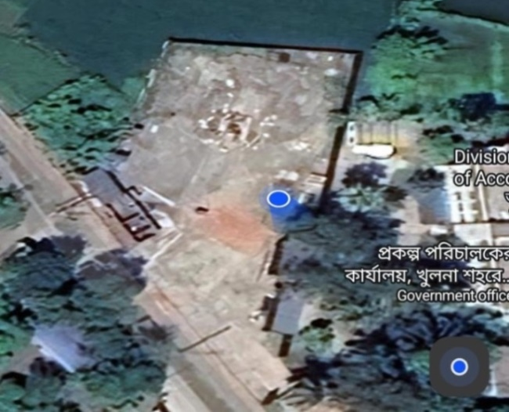

Figure 1: Site Location Map
Site Establishment
The contractor will establish the site with:
- Temporary boundary fencing and gate
- Construction of Site office, Labour Shed & Storage facilities
- Temporary electricity and water supply
- Safety signs and security guard post
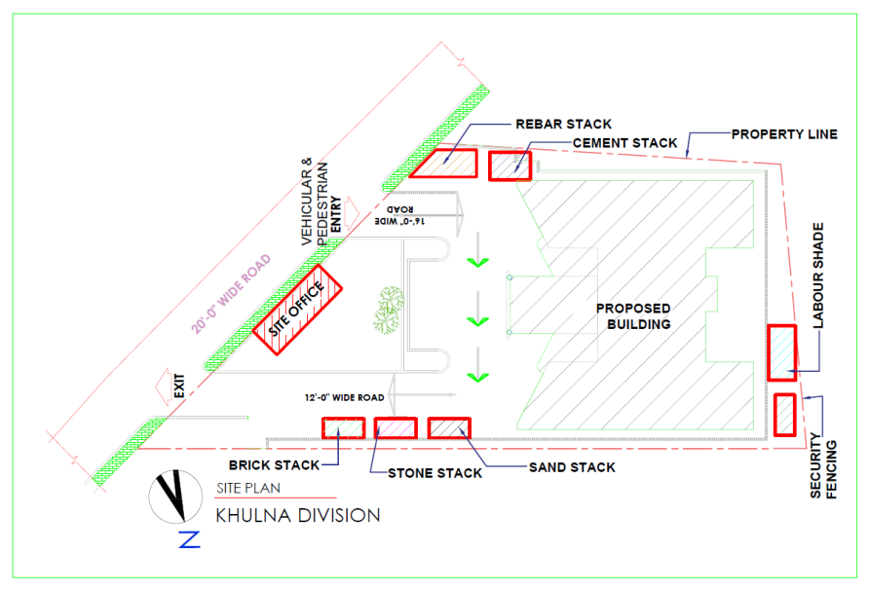

Figure 2: Proposed Site Management Plan for Site Preparation
Site facilities
The following facilities will be ensured:
- Project office & meeting room
- Labour Shed
- Material storage zone
- Equipment storage and maintenance zone
- First aid and emergency facility
- Temporary sanitary facility

3.3 Earthworks
Earthworks scope
- Clearing & grubbing
- Excavation for foundation works
- Sand filling and compaction

Excavation & Disposal
Excavation will be done by:
- Manual labour
- Dewatering pump arrangement if necessary

Disposal
- Disposal of broken pile-head and broken materials
- Disposal at approved dumping location as per instruction of PWD authority

Filling and Compaction
- Sand filling will be done by dredgers as per instruction
- Compaction will be carried out using plate compactor/ roller machine
- Soil compaction test for ground floor will be conducted for quality assurance
Note
** Work described here are to be modified and detailed according to work priority and necessity in site management of particular project.

- Time Management
  - Work Breakdown Structure (WBS)

WBS Code | Activity Name | Description | Duration (month)
1.0 | Site Preparation | Drawing Collection, Site cleaning, levelling, temporary office, store and utility installation | 1
2.0 | Foundation Work | Excavation, Pile casting & driving, Pile cap, Grade Beam | 6
3.0 | Superstructure Work | Column, Beam, Slab, Stair | 7
4.0 | Masonry and Plaster Work | Brickwork, lintels, interior and exterior plaster | 8
5.0 | Finishing Work | Floor, Wall Tiles/ Marble Works, Door Frame –Door shuttering works, Window grill & stair railing works | 8
6.0 | Painting & Polishing Work | Painting & Polishing | 6
7.0 | Electrical and Plumbing Works | Electrical wiring, light fittings, water lines and sanitary fittings | 9
8.0 | External Works | Drainage system, boundary wall, roads and pavement | 3
9.0 | Project Completion and Handover | Final inspection, defect rectification and project handover | 2
4.2 Time Control
Time Schedule Preparation
- A detailed Work Schedule will be prepared using MS Project
- Work Schedule to be updated on monthly basis to overcome any delay making necessary adjustments
Monitoring System
- Weekly meeting report
- Monthly item wise progress report submission
- Submission of image of full Site at monthly progress report
Time Control Activities
- Monthly target setting
- Item wise target setting
- Following & maintaining monthly Bar Chart
- Additional manpower if required
- Proper coordination of Civil and MEP works
- Night shift arrangement during critical works
4.3 Steps of Construction

Sl. | Project Summary | Duration | Work Plan
Sl. | Project Summary | 730 days | Start | Finish
1 | Mobilization & Site Development | 24 | 14-08-25 | 07-09-25
2 | Pre-cast Pile Casting & Driving | 152 | 08-09-25 | 07-02-26
3 | Earth cutting, Pile cap, Short Column & Grade Beam reinforcement placing, casting & sand filling | 72 | 08-02-26 | 21-04-26
4 | Column & Slab reinforcement placing & casting of GF | 30 | 22-04-26 | 21-05-26
5 | Column & Slab reinforcement placing & casting of 1st Floor | 30 | 08-06-26 | 07-07-26
6 | Column & Slab reinforcement placing & casting of 2nd Floor | 30 | 08-07-26 | 07-08-26
7 | Column & Slab reinforcement placing & casting of 3rd Floor | 30 | 08-08-26 | 07-09-26
8 | Column & Slab reinforcement placing & casting of 4th Floor | 30 | 08-09-26 | 07-10-26
9 | Column & Slab reinforcement placing & casting of 5th Floor | 30 | 08-10-26 | 07-11-26
10 | Parapet wall & OHWT, reinforcement placing & casting of Roof Top | 30 | 08-11-26 | 07-12-26
11 | Brick Works | 208 | 07-07-26 | 31-01-27
12 | Electrical Works | 198 | 21-08-26 | 07-03-27
13 | Plastering Works | 167 | 21-09-26 | 07-03-27
14 | Sanitary & Plumbing Works | 242 | 07-09-26 | 07-05-27
15 | Door Frame & Door Shuttering Works | 188 | 08-12-26 | 14-06-27
16 | Window Grill, Stair Railing Works & Aluminium Works | 211 | 08-08-26 | 07-03-27
17 | Floor, Wall Tiles/ Marble Works | 157 | 01-12-26 | 07-05-27
18 | Painting & Polishing Works | 194 | 01-01-27 | 14-07-27
19 | Lift & Fire fighting Installation | 126 | 01-01-27 | 07-05-27
20 | Boundary Wall with Guard Room | 100 | 22-03-27 | 30-06-27
21 | UGWR & Sewerage Line Works, Drain, Road & Deep Tube-well (including Pump House) | 157 | 08-01-27 | 14-06-27
22 | Site cleaning touch up | 36 | 15-06-27 | 21-07-27
23 | Project Handover | 14 | 01-08-27 | 14-08-27
24 | De-Mobilization
Note
** Information given here are to be modified according to different types of works in different projects.
** These charts are to be prepared accordingly following section 4 of CMP guideline.
4.4 Work Schedule for Anti- Corruption Building, Khulna
Name of Work: Construction of Six Storied Anti-Corruption Commission Divisional Office Building with Six Storied Foundation at Khulna. (Civil, Sanitary, Internal Electrification Works, External Electrification: Sub-Station, Generator, Lift, Fire hydrant system, Air-Cooler, CCTV system, Conference system, Sound system etc.) (Tender ID- 1119586).
Work Program for Anti- Corruption Building, Khulna
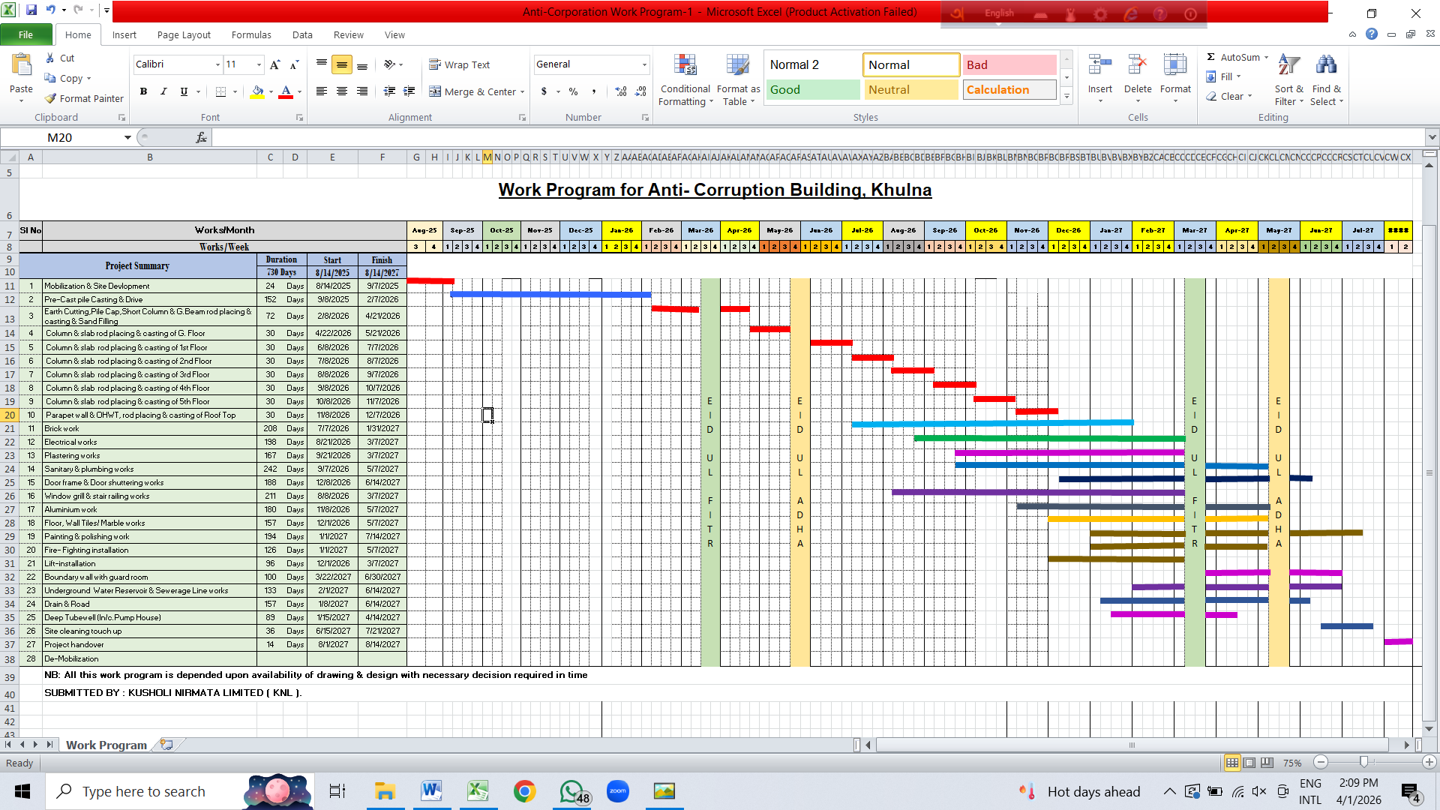
- Resource Management
5.1 Tools & Equipment Plan

Required Equipment List
- Excavator
- Dump Truck
- Concrete Mixer Machine
- Ready Mix Concrete Arrangement
- Concrete Pump
- Vibrator Machine
- Bar Bending and Cutting Machine
- Welding Machine
- Scaffolding and Shuttering Materials
- Plate Compactor/ Roller Compactor
- Dewatering Pump
- Temporary Generator

Equipment Control
- Daily Machine inspection
- Maintenance Schedule
- Operator Training and License Control

Material Receive & Usage log book
Sl. | Date | Material | Received Quantity | Used Quantity | Remaining Quantity | Supplier | Voucher No.
1 | 01-05-25 | Cement | 200 bag | 50 bag | 150 bag | XYZ Ltd. | 1023
2 | 01-05-25 | Sand | 500 CFT | 150 CFT | 350 CFT | ABC Supplier | 4567
3 | 02-05-25 | Reinforcement (60 Grade) | 10 Ton | 2 ton | 8 Ton | Steel Co. | 7890

Equipment Usage & Maintanance Register
Sl. | Date | Equipment | ID No. | Types of Work | Total Time | Operator | Condition/ Remarks
1 | 01-05-25 | Concrete Mixer | EQ-01 | Casting of Foundation | 5 hr | Mr. A | Normal
2 | 01-05-25 | Vibrator | EQ-02 | Slab | 3 hr | Mr. B | Normal
3 | 02-05-25 | Generator | EQ-03 | Supply of Power | 4 hr | Mr. C | Low Fuel

Tools Issue & Return Register
Sl. | Date | Tools | Number | Conditions | Issued to (Name) | Date of Return | Return condition
1 | 01-05-25 | Hammer | 10 | Good | Mr. A | 02-05-25 | Good
2 | 01-05-25 | Spade | 8 | Good | Mr. B | 02-05-25 | 1 nos damage
3 | 02-05-25 | Generator | 5 | Good | Mr. C | 03-05-25 | Good
Note
** Information given here are to be modified according to different types of works in different projects.

5.2 Material Procurement Plan

Procurement Strategy
Procurement will be planned as per construction schedule. Major materials such as cement, rod, sand, stone chips will be supplied continuously as per daily/ weekly requirement.

Procurement and Delivery Process
- Material requisition raised by Site Engineer
- Purchase order issued to Supplier/vendor
- Delivery at site with challan
- Continuous inspection by SAE of Section-1 of Khulna PWD Division 1, Khulna
- Inspection by SDE of Sub-Division 1 of Khulna PWD Division 1, Khulna
- Approval by EE, Khulna PWD Division

Material Storage Plan
- Cement stored in dry covered store
- Sand and stone chips stored separately with boundary marking
- Rod stored on raised wooden sleepers with cover
- Electrical materials stored in locked room

Material Procurement Schedule
Sl. | Material | Total Requirement | Lead Time | delivery Frequency | Safety Stock | Responsible
1 | Cement | 15,000 bag | 3 days | weekly | 100 bag | Site Engineer
2 | Reinforcement (60 Grade) | 400 Ton | 7 days | once in 15 days | 5 Ton | Site Engineer
3 | Sand | 50,000 CFT | 2 days | weekly | 500 CFT | Site Engineer
4 | Brick | 2,00,000 pcs | 5 days | monthly | 2000 pcs | Site Engineer
5 | Stone | 30,000 CFT | 5 days | monthly | 500 CFT | Site Engineer

Procurement Tracking Chart (Status Monitoring)
Sl. No. | Material | Quantity of order | Order Date | Delivery Date | Received quantity | Remaining quantity | Supplier | Status | Comment
1 | Cement | 1000 bags | 02/05/25 | 04/05/25 | 800 bags | 200 bags | XYZ Ltd | Partial | 2 days late
2 | Rebar | 50 ton | 02/05/25 | 07/05/25 | 50 ton | 0 | MNZ Co. | Complete | Timely
3 | Sand | 5000 cft | 08/05/25 | 10/05/25 | 3000 cft | 3000 cft | Local Supplier | Running
4 | Brick | 20000 pcs | 08/05/25 | 10/05/25 | 20000 pcs | 0 | ABC Bricks | Complete | Timely
5 | Stone | 5000 cft | 08/05/25 | 10/05/25 | 3000 cft | 2000 cft | Stone Supply Co. | Running
Note
** Information given here are to be modified according to different types of works in different projects.

5.3 Traffic & Logistics Management
- Materials will be delivered during off-peak hours
- No road blockage
- Traffic flagman during unloading
- Wheel wash facility
- Material hoist within boundary
- Heavy equipment movement and placement plan
- Ready mix concrete delivery trucks management plan
- The road will be constructed using aggregate base layer as required

Register of Resource Management (Sample)
Work | Required Resources | Total Quantity | Time
Foundation work | Excavator | 1 nos | 1-3 month
Foundation work | Labour | 40 man day | 1-3 month
Foundation work | Cement | 800 bags | 1-3 month
RCC work | Rod (unskilled labour) | 60 man day | 4-8 month
RCC work | shuttering (Skilled labour) | 60 man day | 4-8 month
RCC work | Concrete Mixer | 2 nos | 4-8 month
Finishing work | Plaster labour | 40 man day | 9-12 month
Finishing work | paint | 40 man day | 9-12 month
Note
** Information given here are to be modified according to different types of works in different projects.
** These plans & charts are to be prepared accordingly following section 5 of CMP guideline.

- Risk Register
ID | Description of Risk | Probability | Impact | Mitigation
R1 | Accident of Labourer | Moderate | High | Use of PPE, Safety Net
R2 | Delay in supply of materials | High | Moderate | Alternative suppliers
R3 | Heavy Rainfall | Moderate | Moderate | Temporary Cover, Work schedule changes and manpower adjustments
R4 | Excavation collapse | Low | High | Shoring system monitoring
R5 | Failure of Shutter/ Scaffolding | Moderate | High | Ensuring shutter/ scaffolding system as per design and specification
R6 | Falling from height | Low | High | Edge protection, Safety Net
R7 | Fire risk | Low | High | No open wiring, fire extinguishers
R8 | Material theft | High | Moderate | 24-hr security
R9 | Electric shock | Moderate | Moderate | Proper earthing
R10 | Material price fluctuation | Moderate | High | Maintaining minimum stock level
R11 | Late requisition | High | High | Early ordering of long lead items (Lift, Sub-Station, Generator)
Note
** Risk Register given here are to be modified according to different site conditions in different projects.
** This Risk Register chart is to be prepared accordingly following section 6 of CMP guideline.

- Quality Control
7.1 Testing requirements
Materials | Test Name | Time of Test | Place of Test
1. Cement | Compressive Strength Test | For each lot of a particular brand not exceeding 25 tons (500 bags), at least 3 (three) samples collected randomly selected shall be tested. | KUET
2. Reinforcement (Rod) | Tensile Strength Test, % Elongation Test, Bend-Re-Bend Test | For consignment of each size of M.S. bar not exceeding 10 tons, 3 (three) representative samples of each size of M.S. bar shall be tested. | KUET
3. Block | Compressive Strength Test | 1. A sample of 06 blocks shall be selected from each lot of 10,000 units or fraction thereof.  2. If 10,000 unit < lot size < 100,000 unit, then 12 units shall be selected.  3. If lot size > 100,000, then 06 units shall be selected from each 50,000 units or fraction thereof contained in the lot. | KUET
4. Sand | Sieve Analysis | Each day’s casting or per 15 cum of concrete whichever provides the greater number of tests. | KUET/ PWD Testing Laboratory
5. Stone Chips | Sieve Analysis, Aggregate Crashing Value (ACV) | Each day’s casting or per 15 cum of concrete whichever provides the greater number of tests. | KUET/ PWD Testing Laboratory
6. Concrete | Slump test for each ready-mix concrete Vehicle | After arrival of RMC Vehicle | Site
6. Concrete | Concrete Cylinder test | 7 days strength:  *At least one set for  1. Once a day.  2. 60 cum of concrete.  3. 250 sqm surface area  * At least 03 sets for a project.  28 days strength:  *At least one set for  1. Once a day.  2. 60 cum of concrete  3. 250 sqm surface area  * At least 03 sets for a project. | KUET/ PWD Testing Laboratory
7. Sanitary Line | Water pressure test for plumbing line | on the working time | Site
8. LT Cable Test | Conductor Resistance Test | before work | KUET
8. LT Cable Test | Continuity & Loop Resistance Test | on the working time | Site
9. Dry Type  Transformer Test | No-Load & Full-Load Test, Continuity Test | Before approval | Factory
Materials | Test Name | Time of Test | Place of Test
10. Lift and Escalator | Safety Gear & over speed Governor Test, Door operation & Safety contact test, Emergency Stop & Brake Test, Load Test | on the working period | Site
11. 180 TR Chiller Test | Refrigerant Leak Test, Compressor Performance & Efficiency Test | before arrival | Factory
11. 180 TR Chiller Test | Chilled Water flow & Temperature Test, Control Panel & Safety Interlock Test | on the working period | Site
12. Solar System | System Performance Test | on the working period | Site
13. Medical Waste Management System | System Performance Test | after completion of work | Site
14. STP | System Performance Test | after completion of work | Site
15. Fire Protection System | Hydrant Pressure Test | on the working period | Site
16. Medical Gas | Pipe Leakage Test | on the working period | Site
Note
**Material testing plan given here are to be modified according to types of material used in different projects.
** This testing plan is to be prepared accordingly following section 7 & Annexure-2 of CMP guideline.

CONCRETE SAMPLE CYLINDER RECORD SHEET
Sl. No. | Concreting Date | Concreting Area | 7 DAYS |  |  |  |  | 28 DAYS
Sl. No. | Concreting Date | Concreting Area | 7 days completion date | Testing date | Test results receiving date | Test results (psi) | Average test results (psi) | 28 days completion date | Testing date | Test results receiving date | Test results (psi) | Average test results (psi)
1. | 14/02/2025 | Trial Mix | 21/02/2025 | 22/02/2025 | 25/02/2025 | 2740 | 2832
 |  |  |  |  |  | 2925
 |  |  |  |  |  | 2830
2. | 28/02/2025 | Pile Cap group-2 (grid A-I) | 07/03/2025 | 08/03/2025 | 10/03/2025 | 3020 | 2913 | 28/03/2025 | 28/03/2025  (28 days) | 31/03/2025 | 4025 | 4070
 |  |  |  |  |  | 2934 |  |  |  |  | 4188 | 4070
 |  |  |  |  |  | 2785 |  |  |  |  | 3998 | 4070
3. | 10/04/2025 | Column group-2, grid A-D Ground floor 1st lift | 17/04/2025 | 24/04/2025 | 28/04/2025 | 2833 | 2962 | 08/05/2025 | 17/05/2025 (37 days) | 22/05/2025 | 4028 | 4176
 |  |  |  |  |  | 2999 |  |  |  |  | 4155 | 4176
 |  |  |  |  |  | 3055 |  |  |  |  | 4345 | 4176
4. | 14/04/2025 | Column group-3, grid J-L Ground floor 1st lift | 21/04/2025 | 24/04/2025 | 28/04/2025 | 3100 | 2971 | 12/05/2025 | 17/05/2025  (33 days) | 22/05/2025 | 4454 | 4145
 |  |  |  |  |  | 2954 |  |  |  |  | 4245 | 4145
 |  |  |  |  |  | 2860 |  |  |  |  | 3735 | 4145
5. | 21/04/2025 | Column group-2, grid A-D Ground floor 2nd lift | 28/04/2025 | 28/04/2025 | 01/05/2025 | 3033 | 2959 | 19/05/2025 | 25/05/2025  (34 days) | 27/05/2025 | 4299 | 4165
 |  |  |  |  |  | 2958 |  |  |  |  | 4136 | 4165
 |  |  |  |  |  | 2885 |  |  |  |  | 4059 | 4165
Quality Control- Test Report Summary

Note
** This sample of test report summary is given here for example. All the material test reports can be summarized and included here in CMP for proper documentation.

- Health, Safety & Environment (HSE) Plan
- Mandatory PPE (Helmet, Safety Shoe, Vest)
- Safety Net Installation
- Guardrails for height work
- Scaffold Inspection Register
- Fire Extinguisher Installation
- No open wiring
- First Aid Box
- Safety Induction Training & Weekly Safety Meeting
- Emergency Contact List
- Noise monitoring
- Water spraying for dust control
- Covered trucks for material transport
- Waste segregation
- Debris removal within 24 hours
- CCTV for surveillance & 24 hour security arrangement
- Controlled entry/ exit for workers and visitors with register book
8.1 Storm water and Wastewater Management
Storm water Management
- Temporary drains will be made to discharge storm water in KCC drain
- Sump pit and water discharge pump will be arranged if necessary
- Silt trap will be used to prevent mud discharge near KCC drain
Wastewater sources
- Toilets
- Site cleaning
- Concrete washout
Wastewater Management
- Control System
- Portable septic tank arrangement
- Concrete washout pit for mixer/ pump cleaning
- Wastewater will not be discharged directly to KCC drain

8.2 Noise Monitoring
- As per BNBC 2020; Part-07, Section: 1.8.4, all construction & transportation activities in Residential and mixed Residential areas shall be maintained strictly to normal business hours & restricted from 18.00 hours in the evening to 06.00 hours in the morning and on non-working days & holidays;
- Staff at site will be properly trained in using & maintaining tool & equipments;
- Sources of significant noise will be enclosed where practicable;
- Accordingly, where possible all construction traffic to be used on site will have effective well- maintained silencers; and
- All mobile plant will be maintained to a high standard to reduce any tonal or impulsive sounds.

  - Air Quality, Dust Control & Monitoring
- As per BNBC 2020; Part-07, Section: 3.11.3; 1.8.3: Preventive measures shall be introduced against the emission of dust, small particles, toxic gases and also other substances those are hazardous to health by the use of protective devices, local ventilation and exhaust ventilation;
- As per BNBC 2020; Part-07, Section: 3.11.3; 1.8.3: The Contractor shall take all reasonable measures to minimize dust-blow arising from any sites his or her control by regular watering or other effective techniques to any stockpiles, bare soil, and haul roads;
- Vehicles exiting site will use a wheel wash to ensure dust emissions are not generated from tyres;
- Covers will be provided on all vehicles leaving the site so as to minimise dust arising's off site;
- Site roads shall be regularly cleaned and maintained as appropriate;
- Material handling systems and site stockpiling of materials shall be designed and laid out to minimise exposure to wind;
- In periods of dry weather when dust emissions would be greatest, a road sweeper, which would also dampen the road, will be employed in order to prevent the generation of dust.

8.4 Emergency Response Plan
- Emergency Assembly Point
- Fire Extinguishers per floor
- Emergency Contact Numbers
- Evacuation Drill quarterly
Note
** Health, Safety & Environment (HSE) Plan given here are to be modified according to Site conditions of specific projects.
** This HSE Plan is to be prepared accordingly following section 8 of CMP guideline.

- Cost Control
Cost Monitoring
Cost will be controlled through:
- BOQ-based costing
- Material consumption tracking
- Labor productivity monitoring
- Monthly cost report

Billing and Measurement
- Joint measurement will be carried out
- Monthly RA bills will be prepared
- Payment tracking will be done regularly

- Sample Checklist
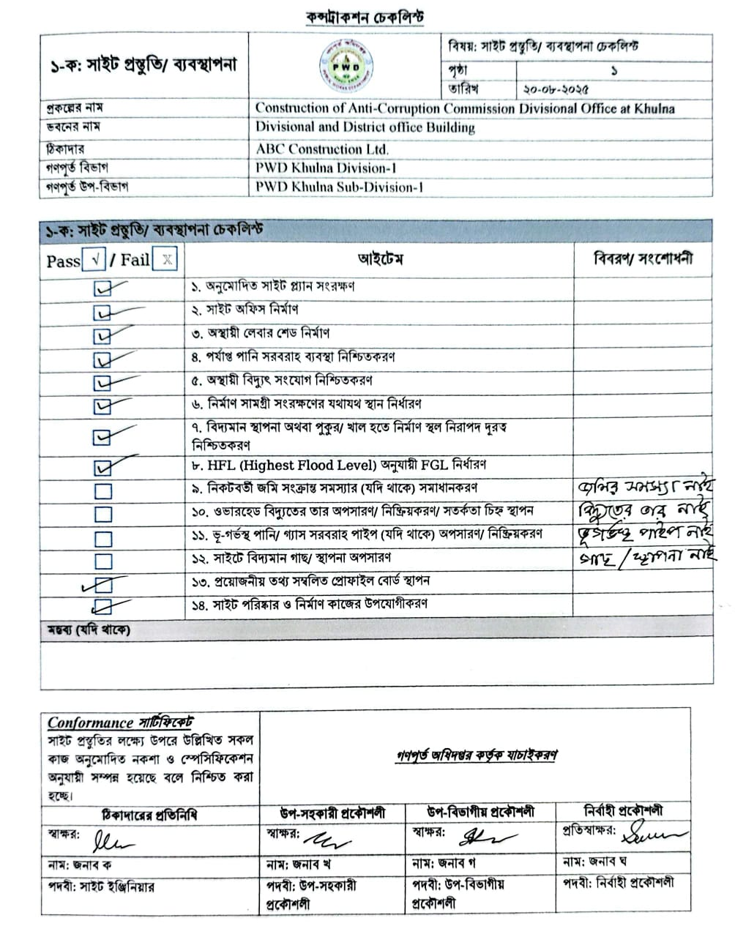

Note
** This sample of filled up checklist is given here for example. All the remaining checklists are to be filled up accordingly and to be included here in CMP for proper documentation.
** The Checklists are given in Annexure-3 of CMP guideline.
- Documentation Checklist
Checklist for Documents preserved at Site
Sl. No. | Documents | Check /  Xক্স  √ | Remarks (if any)
1. | Approved Site Plan | √
2. | Digital Survey Report | √
3. | Copy of approved DPP | √
4. | Soil test investigation report | √
5. | Test Pile Load Test Report | √
6. | Service Pile Driving Record | √
7. | Approved Architectural Drawing | √
8. | Approved Structural Drawing | √
9. | Approved Plumbing Drawing | √
10. | Approved storm water drainage Drawing | √
11. | Approved sewer Drawing | √
12. | Approved internal Electrical Drawing | √
13. | Approved external Electro-mechanical Drawing | √
14. | Approved Fire Detection & Protection Drawing | √
15. | Approved Medical Gas Pipeline System Drawing (if any) |  | Not Applicable
16. | Approved Stage Light & Sound System, Acoustic Drawing (if any) |  | Not Applicable
17. | Contract Documents | √
18. | Bill of Quantities (BoQ) | √
19. | Master Work Schedule | √
20. | Monthly Work Schedule / Gantt Chart |  | will be added upon work completion
21. | Material Test Report (Field Test Report & Laboratory Test Report) |  | will be added upon work completion
22. | Stock Register of material | √
23. | Material approval sheet |  | will be added upon work completion
24. | Log book of material & equipments | √
25. | Site order book | √
26. | Recorded Measurement Book (MB) |  | will be added upon work completion
27. | Duly filled and properly signed Quality Control Checklist |  | will be added upon work completion
Sl. No. | Documents | Check /  Xক্স  √ | Remarks (if any)
28. | Inspection Report |  | will be added upon work completion
29. | Monthly Progress Report |  | will be added upon work completion
30. | Safety Report | √
31. | PWD’s & Contractor’s Manpower Information | √
32. | Labourers’ Attendance Register | √
33. | Drawing Register | √
34. | Construction Management Plan (CMP) prepared for the project | √

- Completion and Handover
Project Completion
Final completion will include:
- Finishing works completion
- Testing and commissioning
- Final cleaning and site clearing
- Submission of Completion Documents

Testing and Commissioning Includes:
- Generator test
- Substation test
- Lift test
- Fire hydrant pressure test
- CCTV and conference system test
- Electrical load test
- Plumbing line pressure test

Completion Documents includes:
- As-built drawings
- Material test reports
- Completion certificate
- Warranty certificates
- O&M manuals for lift, generator, substation, CCTV, fire system etc.

Final Handover
- After approval by ACC & PWD Khulna Division 1, Khulna
- PCR will be issued
- Building will be handed over officially
- Defect liability period will start as per contract condition
Note
** Information given here are to be modified according to different site condition.
** This ‘Completion and Handover’ part is to be prepared accordingly following section 13 of CMP guideline.

